Website Project Report: Nordic Essence

Group 9:
Dehghani Beshneh Mitra: UI Design
Onyido Oluchukwu: Testing and Documentation
Tian Zheng: HTML/CSS Development
GitHubRepository:https://github.com/tianzheng0791/Website-Project-Report-Nordic-Essence.git
WebsiteLink:https://tianzheng0791.github.io/Website-Project-Report-Nordic-Essence/

1. Topic of the SiteTopic: Nordic Essence - A Digital Curator of Finnish Design.
Description: This website is a conceptual gallery and boutique showcasing iconic Finnish interior design, specifically focusing on brands like Artek, Iittala, and Marimekko.
2. Target Audience：
Design Professionals
Art Enthusiasts
Collectors
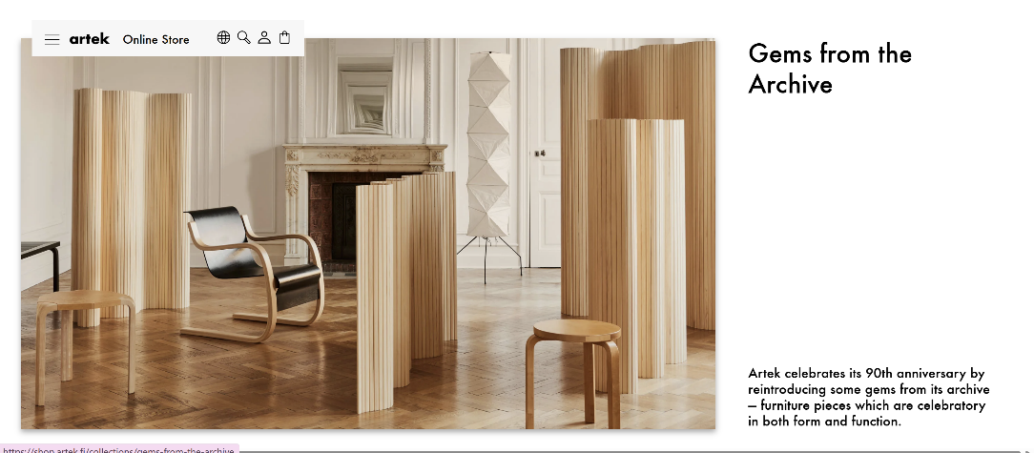
Website look and feel：www.Artek.fi

www.Iittala.com
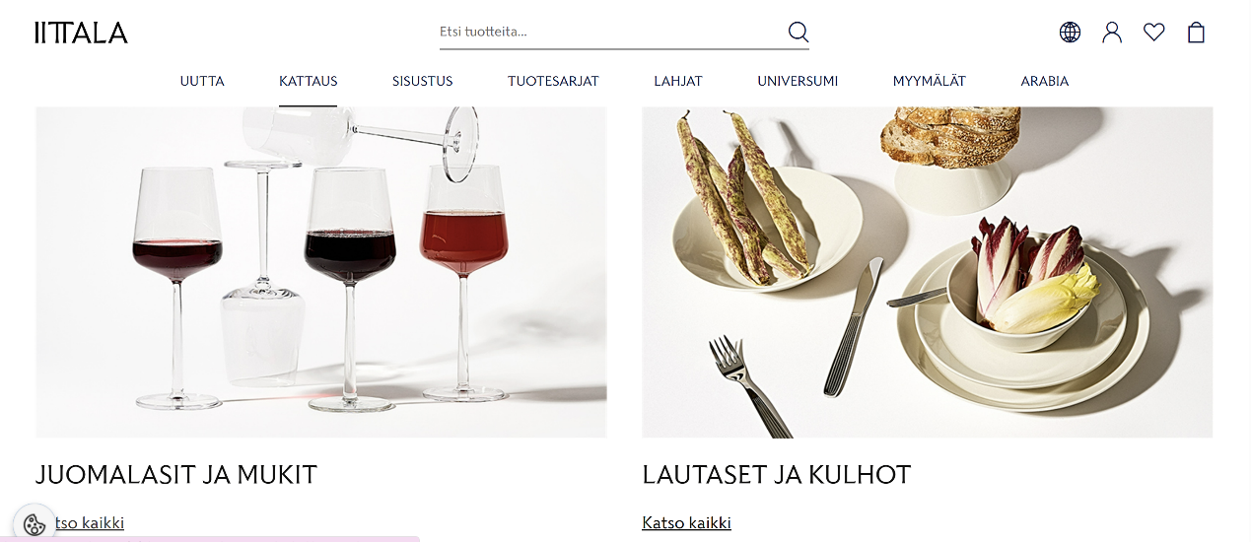

www.tate.org.uk
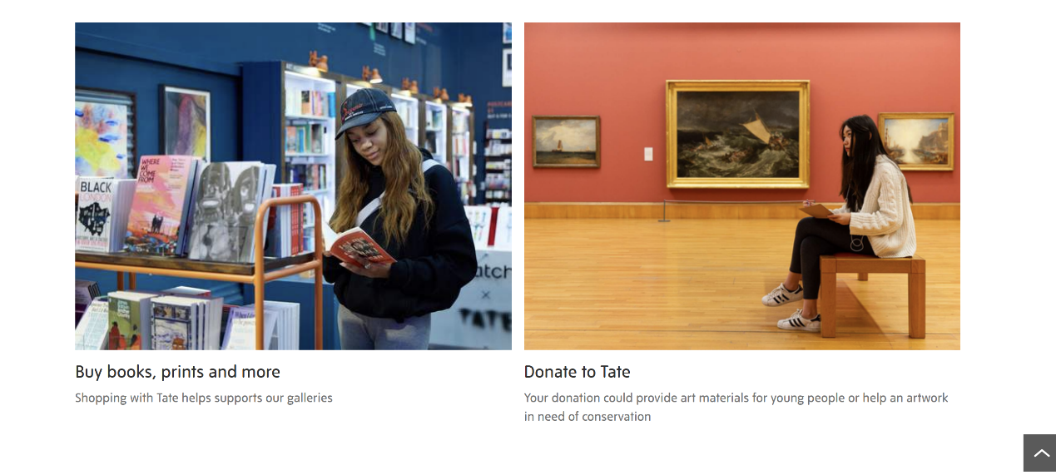
www.metmuseum.org
